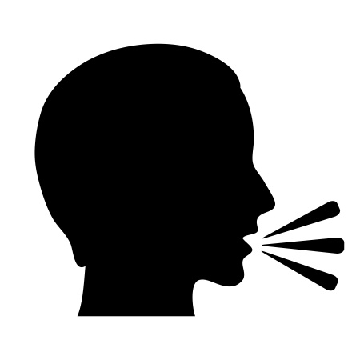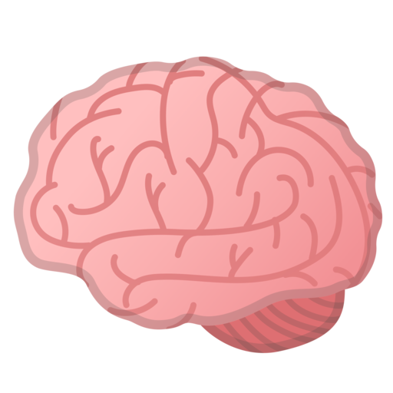

Only One Person Speaks

每次一人发言

Speak Loudly

大声表达你的观点

Raise Hands

举手回答问题

Keep Thinking

保持思考

Listen Carefully

仔细倾听

Look at the Speaker

眼睛看说话的人