Summary & Warm Up

**K2: Ages 5-6**

**Seasons: As An Oak Tree Grows**

**Objectives:**

a) Making comparisons

b) Agree or disagree respectfully with their peers and use correct P4C hand signals

c) Build on each other’s ideas during the discussion

d) Pointing out similarities and differences

e) Reflect on how human affect nature

**Warm Up:** Spot the Difference: The students will work in small groups (2-3 per group). They will be given a «Spot the Difference» camel photo where they have to find the differences between the 2 photos. After several minutes, we will come back together as a group and students will volunteer to share the differences that they found on a larger version of the photo. After this, the teacher will present photos showing different seasons. The students will look at the pictures and will have to tell the teacher how the pictures are: alike or different, change they see.

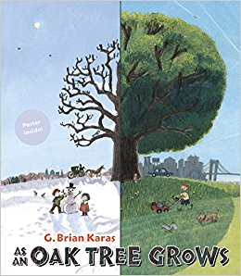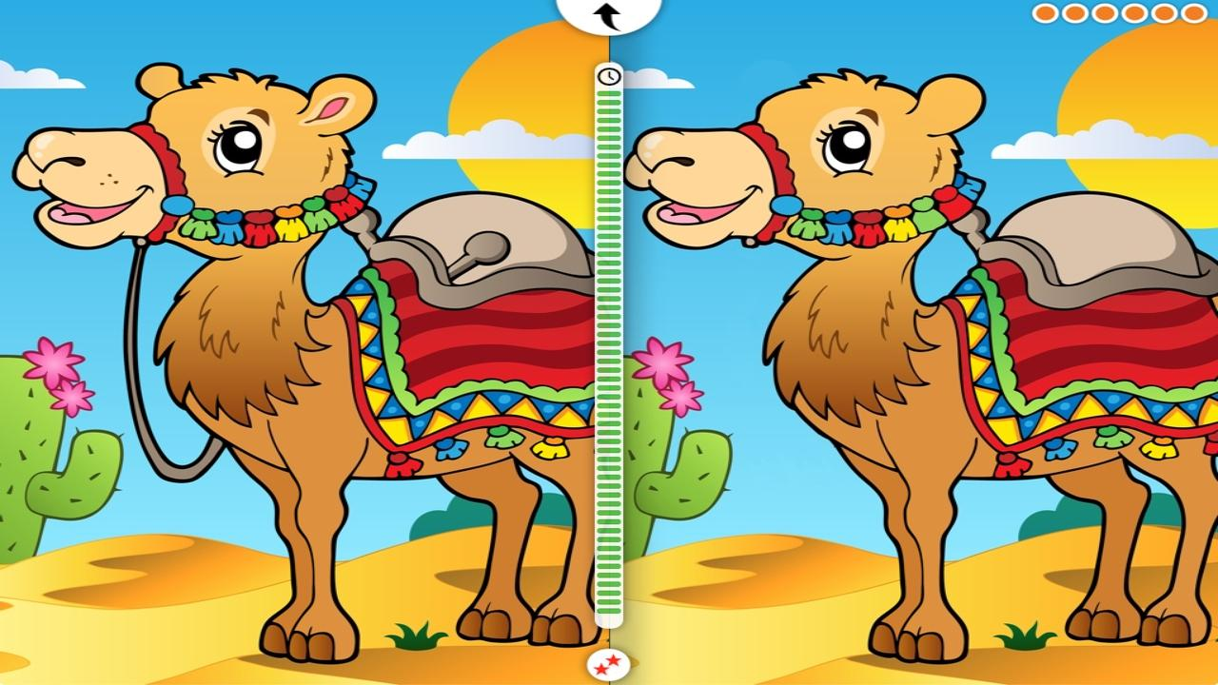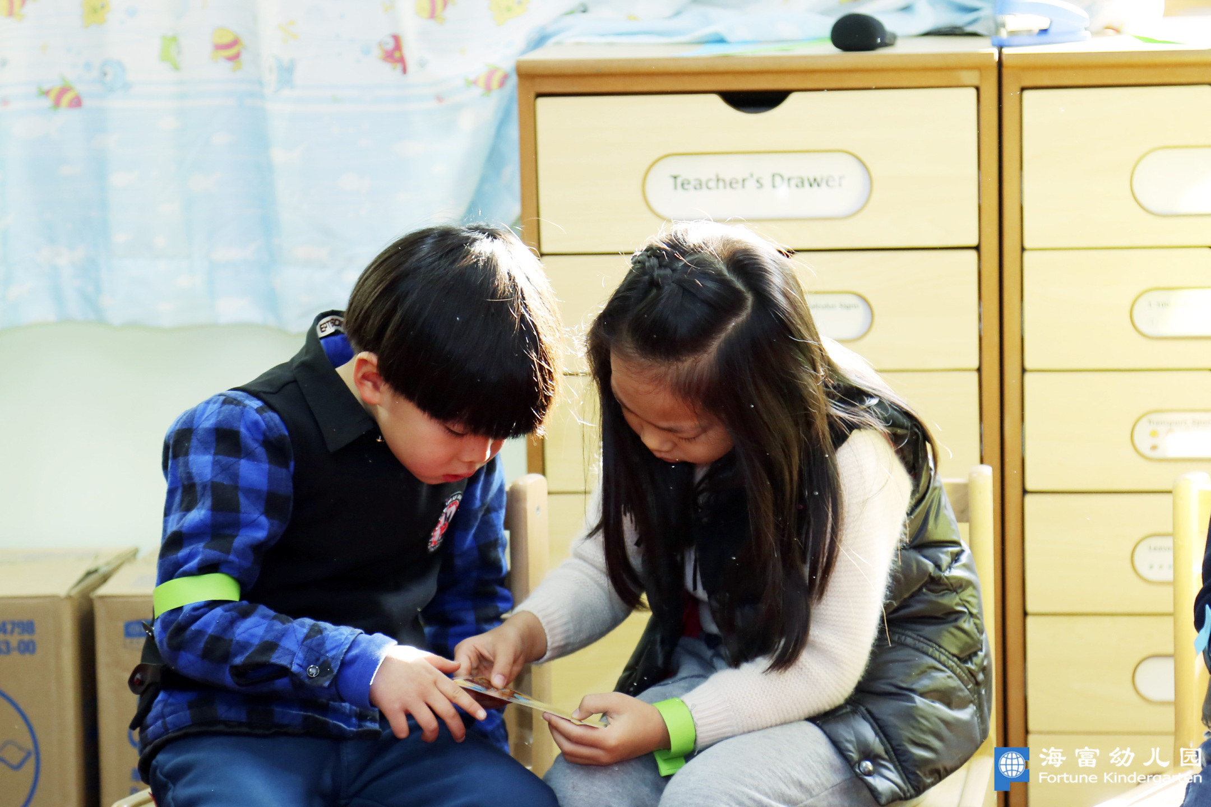

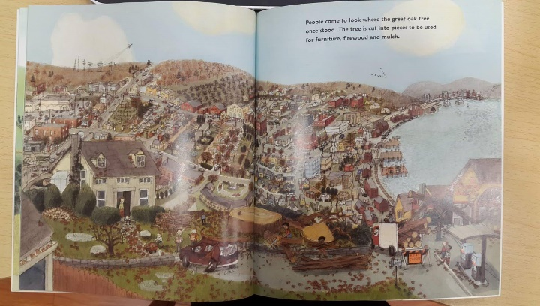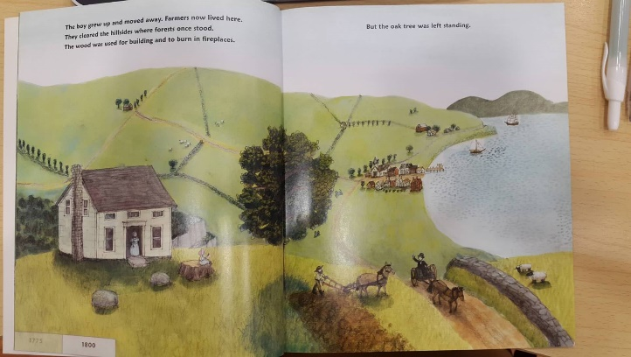

similar

different

caring

Enquiry Step: Stimulus

“As an Oak Tree Grows” (2 photos)

(after showing the 2 photos, the teachers will ask the students to think about the oak tree in these photos. The teacher will ask the student “How do you think the tree feels in the first picture?” Then they will pair & share their thoughts. Then the teacher will ask the students “How do you think the tree feels in the second picture?”. Then they will pair & share their thoughts. After the second pair & share, they will break into groups to develop a question.)

Enquiry Step:

Concept Bulbs & Question Development

1. The teacher will introduce the three concept bulbs (kind, unkind, and sad) and remind students the question should be developed around one of these concepts.

2. Break into 4 groups for question development and come back together for voting.



Enquiry Step: Voting

**Voting Method:** Vote for the favored question by dropping their seasons tree in the voting box

Enquiry Step: Discussion

Split in to two groups:

Group 1: open discussion

Group 2: Children will work together to create a scene showing the four seasons on a large poster.

Enquiry Step: Last Words

-Review thoughts that were shared & ask the children if they were a tree which picture would they rather live in and why.

